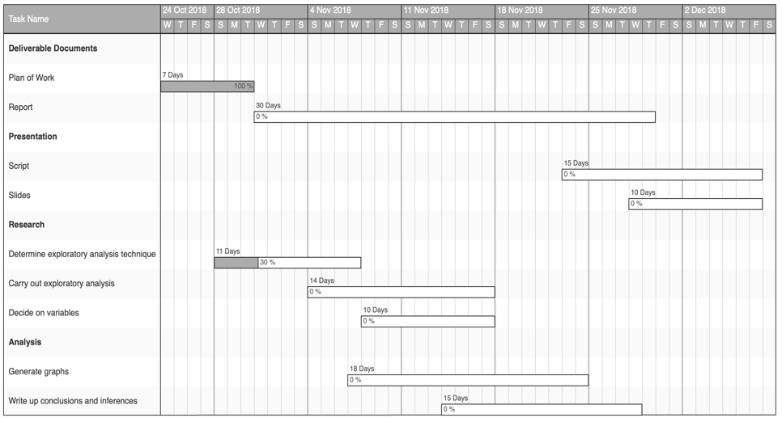

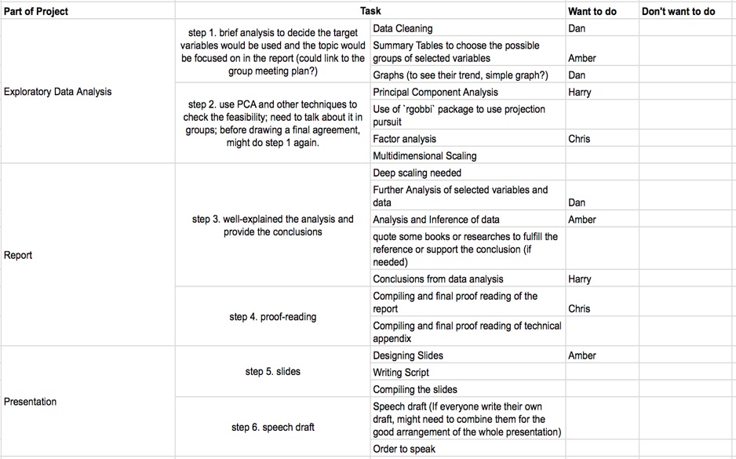

**step 1** to decide the target variables would be used and the topic would be focused on in the report

(Note:)

(simple analysis and graphs before the 2nd Meeting)

(Combine all ideas together in the 2nd or 3rd meeting, because of the feasibility)

(In order to minimize the risk, need plan B of the combination of variables.)

**step 2** use PCA and other techniques to check the feasibility; before drawing a final agreement, might do step 1 again.

(Note:)

(share works in Messenger group or Github to discuss)

**step 3** well-explained the analysis and provide the conclusions

(Note:)

(need to improve the graphs)

(while explaining, might need to quote some materials) (maybe some from the readings recommended in the moodle page? Could make it easier)

**step 4** proof-reading

**step 5** slides

**step 6** speech draft